**Activity 2: Installing lamp server on ubuntu**

* Note: we will skip mysql installation for now
* Manual steps are

sudo apt update

sudo apt install apache2 -y

sudo apt install php libapache2-mod-php php-mysql -y

# Create a file called as /var/www/html/info.php with below content

# <?php phpinfo(); ?>

sudo -i

echo '<?php phpinfo(); ?>' > /var/www/html/info.php

exit

sudo systemctl restart apache2

* <https://github.com/asquarezone/AnsibleZone/commit/5273ac75e8fc117bebea87cd4e6afd37589e2139> for the changset containing playbook, inventory and file
* Check for syntax of playbook

ansible-playbook -i <inventory-path> --syntax-check <playbook-path>

* Now lets run the playbook ansible-playbook -i <inventory-path> <playbook-path>  
  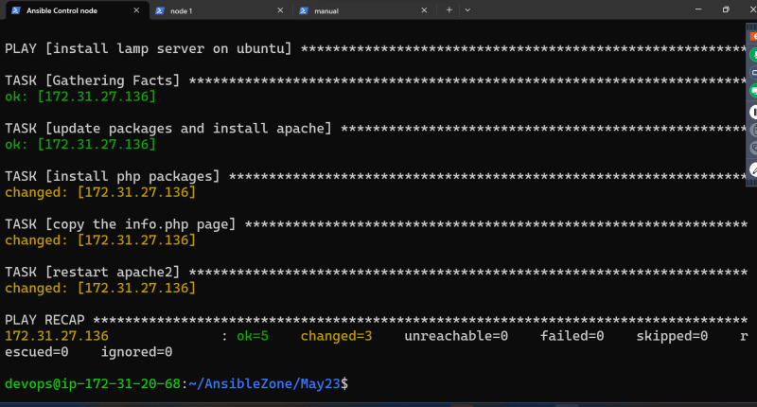
* Verify the installation  
  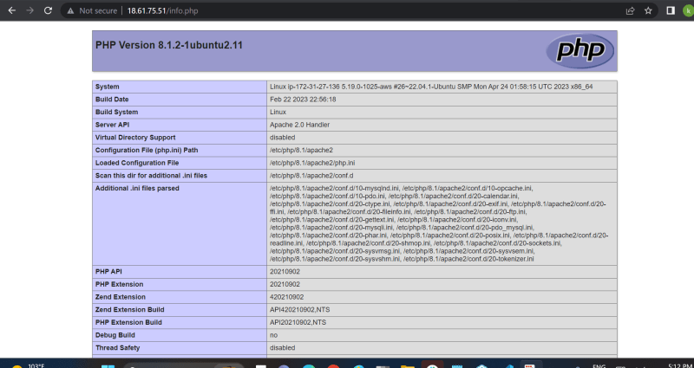
* Problems to be addressed
  + during every playbook execution the apache service is getting restarted  
    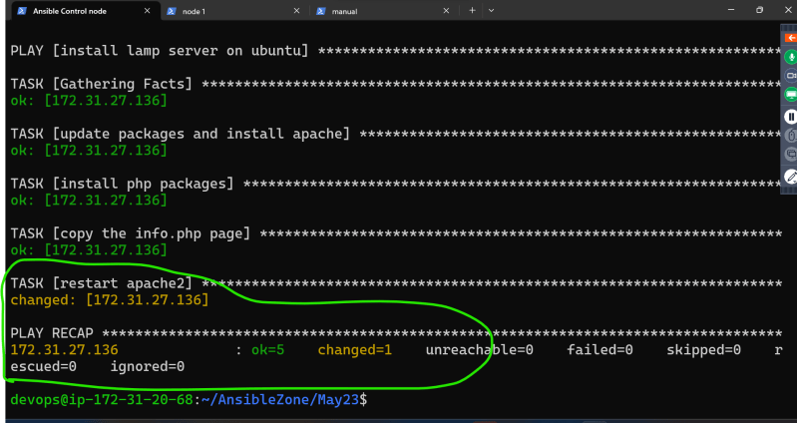

**Activity 3: Install lamp stack on Redhat 9**

* Manual steps

sudo yum install httpd -y

sudo systemctl enable httpd

sudo systemctl start httpd

sudo yum install php -y

sudo -i

echo '<?php phpinfo(); ?>' > /var/www/html/info.php

exit

sudo systemctl restart httpd

* <https://github.com/asquarezone/AnsibleZone/commit/d9fe2cbe5bfeba417e8020dc38ea55edb5e7fabf> for the changeset for redhat
* Execute playbook  
  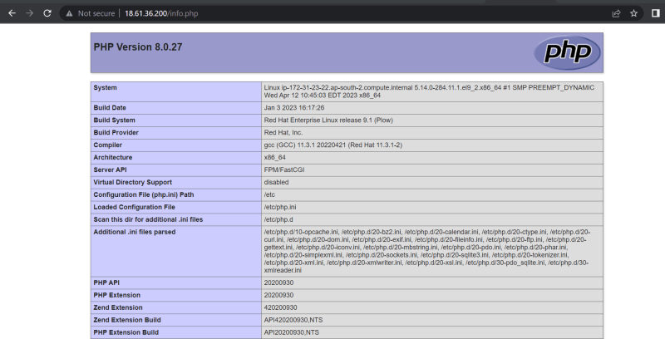
* Problems
  + during every playbook execution the apache service is getting restarted
  + Why should we have two inventory files one for ubuntu and one for redhat
  + Can we have one playbook for both redhat and ubuntu
  + Bailout with proper failure message for unsupported operating systems

**Exercies**

* Write playbooks to install the following on ubuntu 22.04
  + java 17
  + .net 7
  + nginx